Starforge Printing is a platform where anyone can go to get quality 3D prints just by uploading an STL. You choose what material you want your model printed in and a quote will be sent back with a list of different quantities and the prices for each. The project is self-acquired since our Etsy shop has seen great success selling 3D printed items and custom prints are in high demand.

Research
- Treatstock- Middle man platform that offers 3d printing, cnc, and cutting services. There are reports that this company takes a long time to send payouts to customers if at all.

- Craftcloud- A broker platform that connects users with companies who provide 3d printing cnc machining, metal fabrication, and casting/molding services. Prices vary depending on want company you ultimately chose for your project.

- Shapeways- Offers CNC machining, 3D printing, and wax casting. Generally, a popular and trusted service that has only improved since it was taken over by new management last year.

Use Cases
- Create Account
- Login to account
- Delete account
- Upload STL
- Request Quote
- Make payment
- Order Tracking
- Cancel Order
- Adjust model infill strength
- Adjust model outer wall layers
- Order status
- Report order issue
- Adjust order quantity
- Edit product name
- Adjust model scale
- Generate Sales report
- Manage Customer Order
- Send Quote
- View Print success report
- Update order status

WBS
- Frontend
1.1 Account Management
- Create Account
- Login To Account
- Delete Account
- Password Reset
1.2 3D Model Management
- Upload STL
- Adjust Model Size
- Adjust Model Strength
1.3 Order Management
- Make Payment
- Track Order
- Request Cancellation
1.4 Customer Dashboard
- Uploaded Models
- Order History
- Account Settings
- Backend
2.1 Payment Processing
- PayPal Integration
- Tax Collection
- Shipping Calculation
2.2 Authentication
- Login Storage
- 2FA
- Login History Log
2.3 3D Model Processing
- File Storage
- 3D Model Auto Slicing
- Price Calculation
  - Quote/Pricing
- Price of material
- Price for Quantity
- Auto Quote Estimation

Gantt Chart
ID | Name | Week 1 | Week 2 | Week 3 | Week 4 | Week 5 | Week 6 | Week 7
1.1 | Account Management
1.2 | 3D Model Management
1.3 | Order Management
2.1 | Payment Processing
2.2 | Authentication
2.3 | 3D Model Processing

Backlog
-Login
- Account Registration Priority=High
- Account Login Priority=High
- Change Password Priority= Medium
- Account Logout Priority= Medium
- Account Deletion Priority= Medium
-Ui for operator and user
- Homepage Priority=High
- About Us Priority=High
- Account Setting Priority= Medium
- Upload STL Page Priority= Medium
- Adjust Model Size Priority= Medium
- Adjust Model Color Priority= Medium
- Adjust Model Strength Priority= Medium
- Get Model Quote Priority=High
- Cart Priority=High
- Payment Screen Priority=High
- Order Tracking Screen Priority= Medium
- Contact Us page Priority= Medium
- Uploaded Models Page Priority= Medium
- Quantity Selection Widget Priority=High
- Quote Approval Screen Priority= Medium

-Backend processes for operator and user
- Account Storage Priority=High
- 3D Model Storage Priority=High
- Quote Storage Priority=High
- Quote Calculation Service Priority=High
- Messaging Service Priority= Medium
- 3D Model Slicer Priority=High
- Shipping Calculation Priority=High
- Price Calculation Priority=High
- 2FA Priority= Medium
- Order Payment Processing Priority=High
- Order Tracking Updater Priority= Medium
- Refund System Priority= Medium
- Refund Processing Priority= Medium
- Email Notification Service Priority= Priority= Medium
- Review System Priority= Priority= Medium
- Inventory Updater Priority=High
-Reporting for operator and user
- Order History Log Priority= Priority= Medium
- Login History Log Priority= Priority= Medium
- Earnings Report Priority=High
- Uploaded Models Report Priority=High
- Messaging Report Priority= Low
- Delivery Report Priority= Low
- Review Report Priority= Low
- Traffic Report Priority= Low
- Print Success/Failure Report Priority= Low
- Print Completion Time Report Priority= Low

Risk Factors
- Technical
- File compatibility- Customers may upload outdated or corrupted STL files
- File Security- Customer STL files could be compromised in a security breach
- Slicing Failure- The slicing programs may not use the right settings when converting the model to a printable object
- Quote Failure- The quoting system may not give an accurate estimate for the
- Schedule
- Print Delay- Do to failures or a surplus of order, prints may not make it out on time before the due date.
- Testing Delay- Printers might fail during the testing phase
- Implementation Delay- Implementation of the payment or quoting systems may take longer than expected
- Launch Date Change- Stockholders may request that the launch date be moved
- Financial
- Slicer Software Licenses- Software licenses may need to be purchased for slicer integration
- Security Costs- Security costs could increase as development progresses
- Storage Costs- File storage needs will increase with more customers
- Shipping Costs- Shipping costs may fluctuate greatly between different locations and seasons
- People
- Developer Absence- Developer could be absent or quit during a critical time
- Unskilled Developer- Developer may not be as skilled as advertised
- Developer Communication- Developers may not communicate effectively causing the same work to be done by multiple different
- Requirements- Stakeholders may take long to specify requirements, especially for new developments

Risk Register
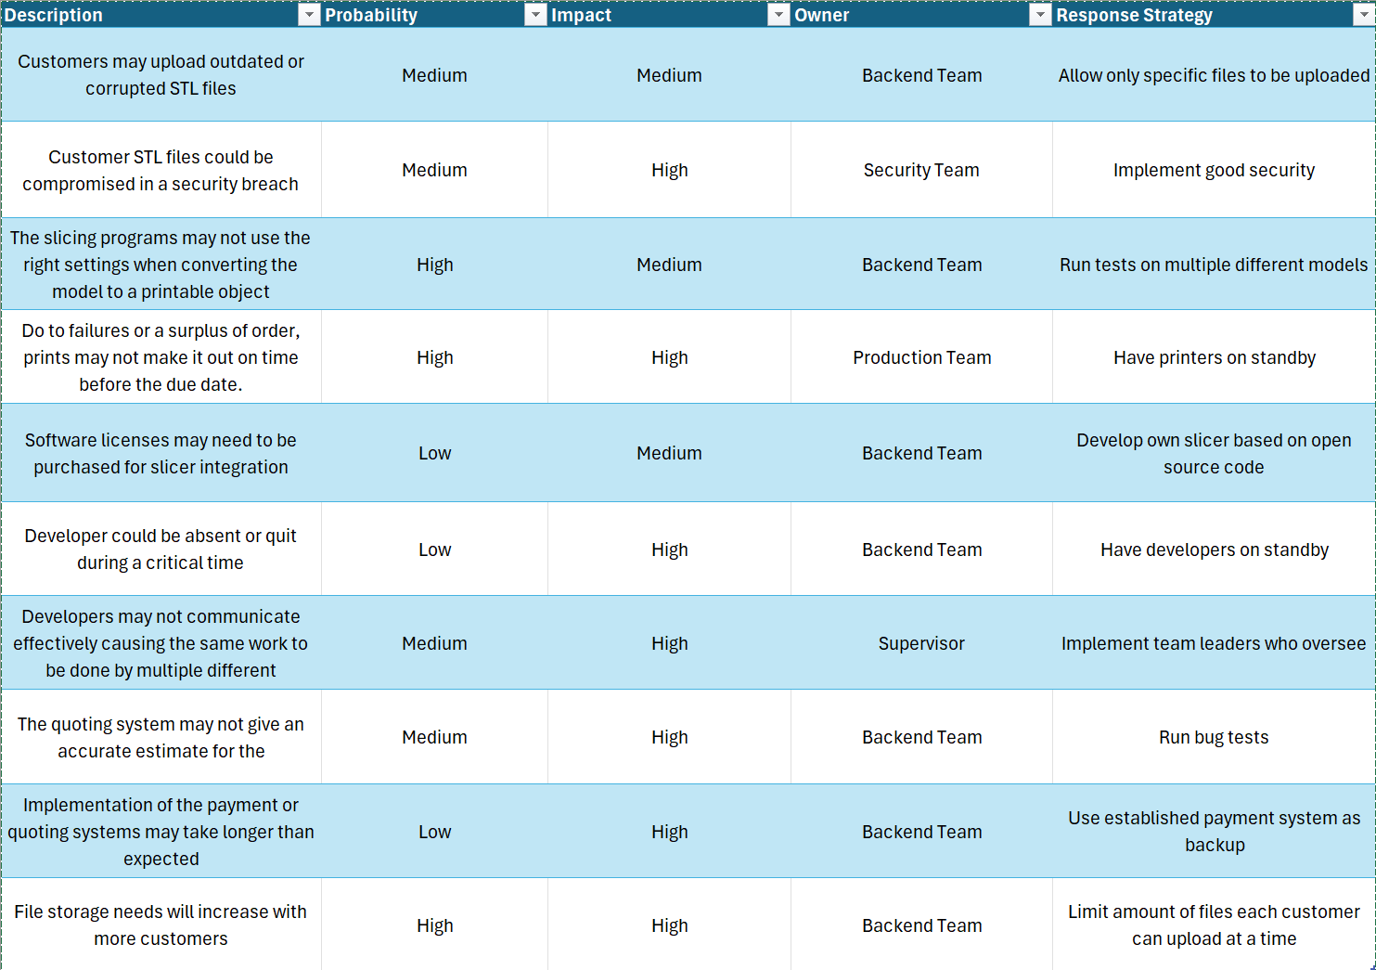

Communication Plan
Backend Team- Meetings held twice a week on teams
Production Team- Meetings held weekly in person
Security Team- Meetings held bi-weekly on teams unless there’s an emergency
Supervisors- Meetings held weekly on teams

Roles & Resources
James Lee – Developer – Low Skill - 100%
Morgan Black – Project Manager – High Skill – 100%
Johnny Silverhand – Quality Assurance – Medium Skill – 100%
Dave Patel – User Experience – Low Skill – 100%
Dexter Morgan – DevOps – High Skill – 75%
Walter White – Business Analyst – High Skill – 50%
Jesse Pinkman – Product Owner – Medium Skill – 100%
Rick Grimes – Subject Matter Expert – High Skill – 25%

- Team assumptions and per-role annual cost (hours * rate):​
- - PM: (672 hours * $80/hr) = $53760
- - Developer: (672 hours * $50/hr) = $33600
- - QA: (672 * $60/hr) = $40320
- - UX: (672 * $50) = $33600
- - DevOps: (504 * $75) = $37800
- - BA: (286 * $75) = $20100
- - PO: (672 * $75) = $50400
- - SME: (168 * $70) = $11760
- Labor subtotal = 53760 + 33600 + 40320 + 33600 + 37800 + 20100 + 50400 + 11760 = 281,340
- Infrastructure & other costs = Cloud 1,000/month * 12 = 12,000; Licenses 4,000; APIs 2,400; Security 5,000; Hardware 20,000; Training 5,000 ->subtotal = 48,400
- Overhead/Benefits (25% of labor) = 0.25 * 281,340 = 70,335
- Grand total = 281,340 + 36,412 + 70,335 = 388,087

Task / Role | Dev | PM | QA | UX | DevOps | BA | PO | SME
Requirements | I | A | R | I | C | I | C | I
3D Model Management | C | I | A | R | C | C | I | I
Order Management | I | R | I | I | C | I | C | I
Payment Processing | A | I | C | C | C | I | C | I
Authentication | R | I | C | I | C | C | I | A
3D Model Processing | I | C | I | I | R | A | I | I
UX | C | I | C | A | I | C | C | I
Account Management | I | I | I | C | A | R | I | I
Testing | I | C | C | I | C | I | A | I
Release | C | I | C | I | I | I | R | I

Stakeholder Grid
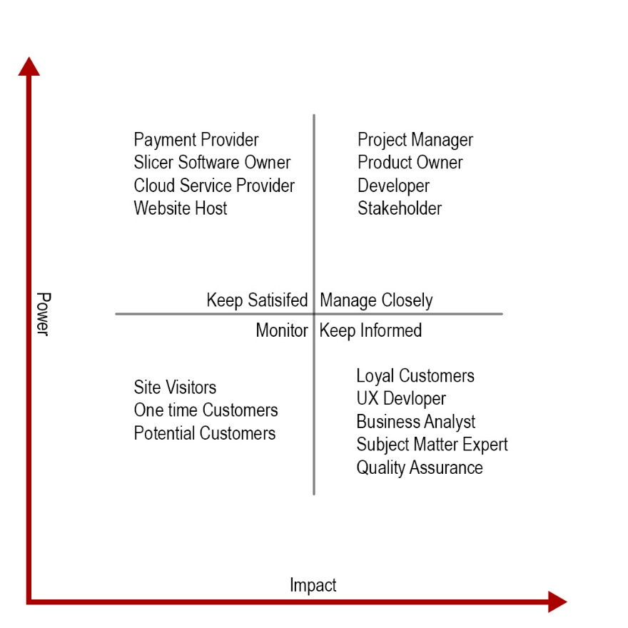
Project Charter
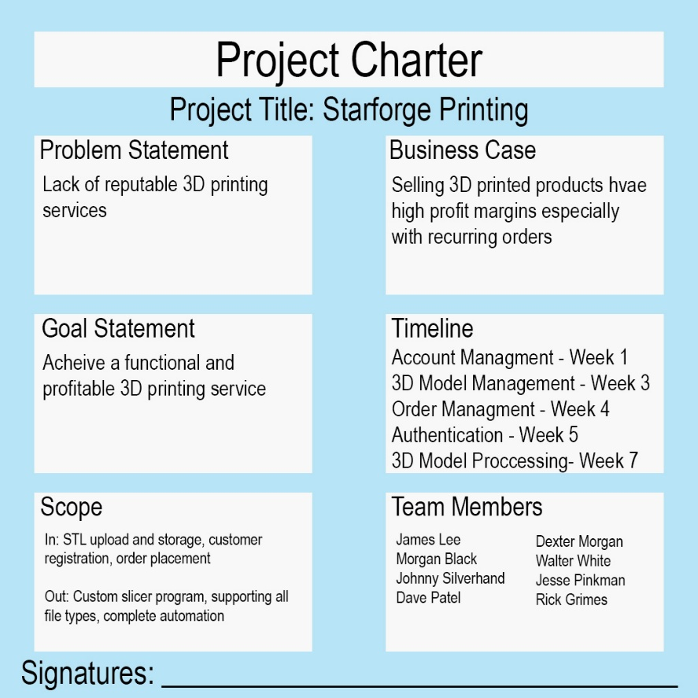
Team Charter
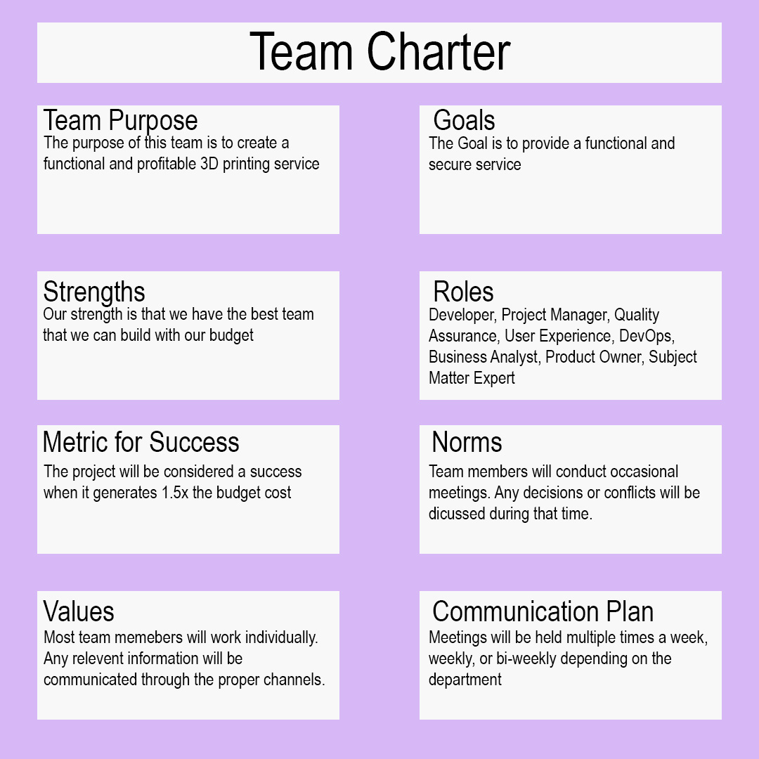

Project Closure Report
Executive Summary

Starforge Printing goal is to provide an online 3D printing service where customers upload their own STLs to have printed. Customers can customize different properties for their print, which affects the price of their quote. Quotes are automatically calculated based on the print time and material specified. The system aims to be mostly automated to reduce human interaction required to make a sale. This document establishes the requirements, team, and budget required to successfully complete the project.

Achievements and Shortfalls

Achievements
- Established Use Cases
- Created WBS Plan
- Developed Gnatt Chart
- Set Priority for Backlog Items
- Listed Risk Factors
- Established Communication Plan
- Reviewed the Roles and Resources
Shortfalls
- Quote calculation needs refinement
- Complex Models May Require Special Settings
- System Does Not Account for Print Failure Risk
- May not have enough storage if demand increases
- Security requirements may not be sufficient to protect customer information

Lessons Learned
The main lesson that was learned was to not underestimate the project cost. Another one is to make sure time is allocated for unexpected problems or delays. The final one would be to have a clear understanding of the risks to avoid problems.

Recommendations for Future Projects
- Test Quoting system
- Increase time for each goal
- Test entire customer experience

